Project Overview

As student debt continues to grow it raises the question the value of a given degree and its long-term ROI. We will be looking at federal student loan data and loan defaults by state. We will explore how student loans and default rates vary across factors such as institution type, program length, geography, degree type of institutions and graduation rates.

Data Set Links

Federal Student Aid – US Dept of Education - https://studentaid.ed.gov/sa/about/data-center/student/default

College Insight - <http://college-insight.org/#explore/go>

College Scorecard – US Dept of Education- <https://collegescorecard.ed.gov/data/documentation/>

Visualization Screen shots

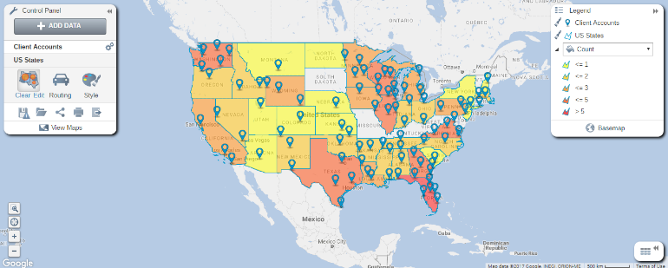

Additional bar charts comparing default rates using other factors.

Final design sketch

We will map default rates and average loan payments by state on the same baselayer map using a toggle to select either statistic overlay. We will then use a series of charts to analyze how other factors such as cost of school and institution type drive default rates. We will create a dashboard and display via an HTML page. We will use an undetermined JS library for charting.

Git Hub Link

<https://github.com/mugdha0705/Project2.git>